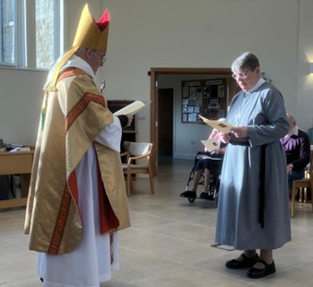
On Sunday 2nd February Archbishop Stephen join us for the morning Eucharist.
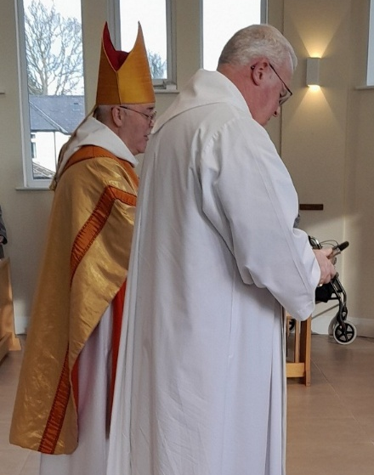
It was a busy morning, as during the service Sr Jocelyn received a special blessing to mark her 2nd term in office as Prioress;

Fr Paul received
his licence for his
2nd year as our Chaplain;

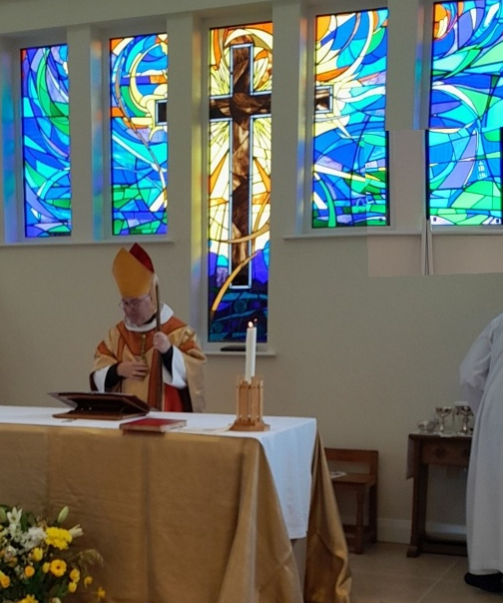

and at the end of the service
the Archbishop blessed our new
Chapel Window.
It was a particular pleasure to be
joined by Andrew Brepi, who
designed and made the window,
and his wife Laura and by some of
the folk who contributed in
memory of loved ones.

After the service we all enjoyed coffee and fellowship together.
