Oasis of Silence

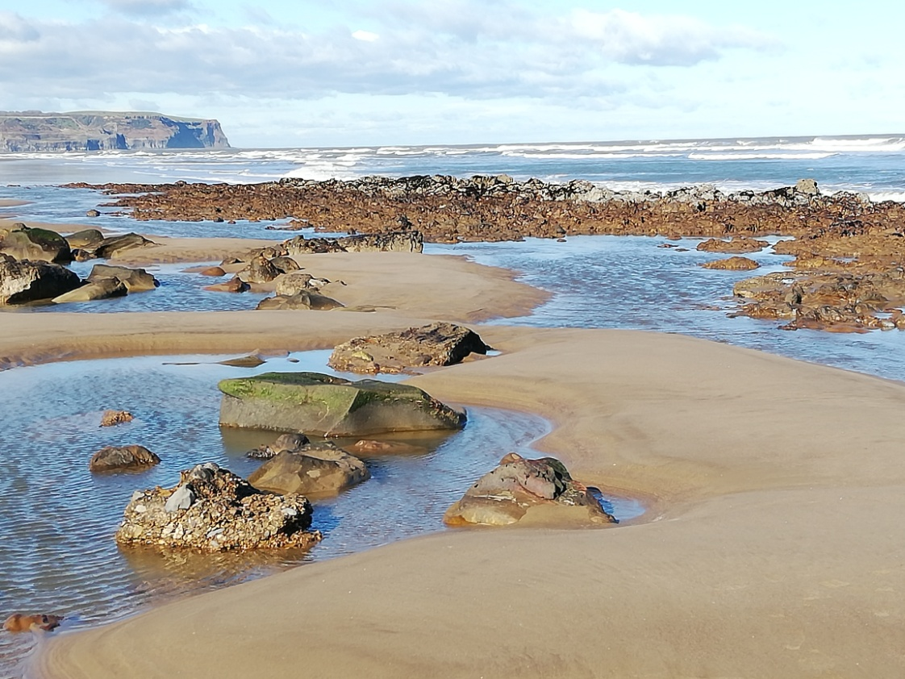

St. Hilda´s Priory,
Whitby
2025

Come to me,
all you who are weary and burdened,
and I will give you rest.
You will find rest for your souls.
(Matthew 11,28)

The Oasis of Silence programme at St. Hilda´s Priory offers space and stillness to seek God with loving awareness in the present moment. It offers a variety of opportunities to make retreats of different lengths in a peaceful and welcoming environment, away from our busy everyday lives.

It is for everyone seeking stillness and silence and who is interested in getting to know or to deepening the practice of contemplative prayer.

“There are many techniques leading to contemplative prayer,” the Jesuit, Franz Jalics SJ (1927 – 2021) used to say, “I teach only one of them.” We keep to the form and the dynamics of his method (also known as the Gries Path) in this retreat programme. Through a deepening awareness of the reality of the present moment by focusing on our breathing, our hands and His Name we are led to a ever deeper encounter with Jesus Christ

- Link for information on courses !!

One day retreat courses: Oasis of Silence 9.30am to 4.30pm

This Saturday retreat is an opportunity to spend a day once a month in contemplative prayer. Everyone is welcome! The guided meditations in the morning help both beginner and those with more experience to leave the business of their lives and become aware of the presence of God in the present moment.

Arrivals from 9.30 for the chance of a cuppa and chat before 10 am start.
Then guided meditations before enjoying a simple lunch (soup and a roll) together in shared silence. The afternoon session begins with a reflection on Scripture before time spent alternately in meditation or in the peace and quiet of the lovely Priory gardens. The day finishes around 4.30 pm

This retreat is also a regular meeting point for anyone on the contemplative path and offers opportunity for individual conversations with the retreat guide, both during and after the retreat.

You are very welcome to make a weekend of it by using the Priory bed and breakfast possibilities. However, please note that the prices to be expected are then standard prices, NOT retreat rates).

Proposed dates for 2025

18th January 12th April 19th July (not in August/September)
8th February 24th May 18th October
15th March 21st June 22nd November
13th December

Lent course Weekly course over 5 weeks
This course is an introduction to the Jesus prayer in every day life using the Gries Path. Week by week our increasing awareness of the reality of the present moment brings us to a deeper encounter with Jesus Christ.

More information about dates and times on request.
4 day retreat “Tasting the Silence”

Spring retreat: Thursday 1st to Sunday 4th May 2025
Autumn retreat: Monday 20th to Thursday 23rd October 2025

This short form, simple and clearly led, offers the possibility of moving towards contemplative prayer for those not used to extended time spent in silence. We stay in silence before God in silent meditation as a group as well as individually outside in nature. These days of prayer are a school of awareness: listening, looking, alert and open with all our senses to the here and now. What is important is to be willing to remain lovingly alert to the silence and to be open to God´s presence in each moment wherever you are.

10 day Silent retreat Mon 30th June to Thursday 10th July 2025
This retreat course, conceived and developed by Franz Jalics SJ, invites to a long and intensive time of silence (during the whole retreat), a school of awareness of the present moment leading to the Jesus prayer. The only prerequisite for this form of retreat is a true longing to be one with God in prayer and a normal state of mental resilience.
After an introductory period the daily schedule invites to several hours of silent meditation as a group as well as time spent outside in nature individually, participation in the Eucharist (whenever possible), and up to an hour of light manual work (either in the house or in the garden) daily. Individual accompaniment as well as times of sharing in the group is also an important part of the retreat.

For more information or registration, please contact:
Sister Helen Stout St. Hilda´s Priory, Castle Road, Whitby, YO21 3SL
Email: hospitality@ohpwhitby.org.uk Tel. Nr. 01947 899600 or 07595 215083

Accommodation is in individual en suite rooms (2 disabled friendly) with all meals provided. Costs remain high, but suggested donations are deliberately low for our retreats to aid anyone called to them make to be able to do so.
Suggested donations: 1 day retreat: £ 5
4 day retreat: £ 180
10 day retreat: £ 580

