Sr Janette RIP
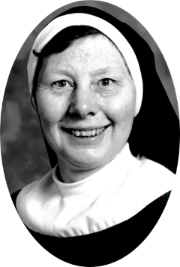
3rd November 2024
After 59 years in Profession it is with great sadness that we announce the death of our Sr Janette after a long illness during which she was cared for at the Victoria Care Centre in Middlesbrough.
Her death came very peacefully on Sunday afternoon and we would like to thank the staff who gave her such excellent care during her illness.
May she now Rest in Peace

