
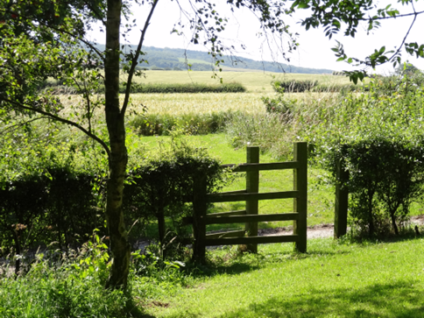
FRIENDS Of O.H.P

WHO?

Anyone
Who would like to be linked with O.H.P.
and who would value the mutual support
of Sisters and Friends.

This may be through
Prayer (if that is part of your life)
Visiting us
(at the Priory or Branch House)
Donations
And diverse ways of expressing friendship

Application form to become a Friend of the Order of the Holy Paraclete

TITLE . . . . . . . FIRST NAME(S) . . . . . . . . . . . . . . . . . . . . . . . . . . . . . . .

SURNAME . . . . . . . . . . . . . . . .

ADDRESS . . . . . . . . . . . . . . . . . . . . . . . . . . . . . . . . . . . . . . . . . . . . . . . . . . . . . .

. . . . . . . . . . . . . . . . . . . . . . . . . . . . . . . . . . . . . . . . . . . . . . . . . . . . . .

TEL.NO. . . . . . . . . . . . . . . . MOBILE . . . . . . . . . . . . . . . . . .

Email . . . . . . . . . . . . . . . . . . . . . . . . . . . . . . . . . . .

If you have any enquiries or would like further information about the Order, please contact: St. Hilda’s Priory, Castle Road, Whitby, North Yorkshire, YO21 3SL
Tel.01947 899560 email: info@ohpwhitby.org.uk w.ohpwhitby.org.uk

