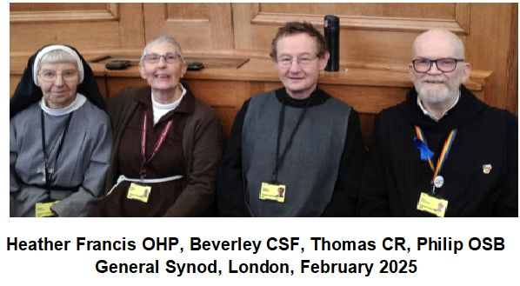
A frequently asked question of those of us in the religious life is
“What do you do all day?”
Well, here’s what members of four different communities were doing last week as they represented the Religious Life on General Synod.

