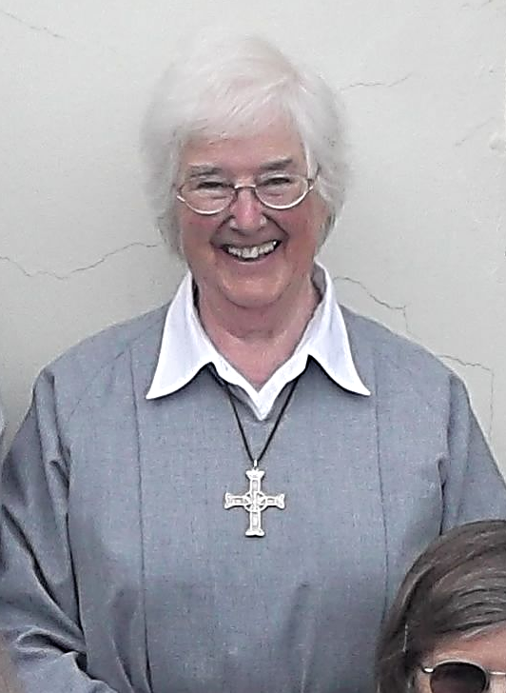
Sr Janet Elizabeth
It is great sadness that we share the news that Sr Janet Elizabeth passed away on the evening of 4th October after a short illness.
May she Rest in Peace and Rise in Glory
Her funeral will be on Friday 24th October at 12.00noon. If you would like to attend please let us know by email: info@ohpwhitby.org.uk
Or by phone: 01947 899560

